Welcome to St. Timothy Evangelical Lutheran Church
February 7th & 8th
Fifth Sunday After Epiphany

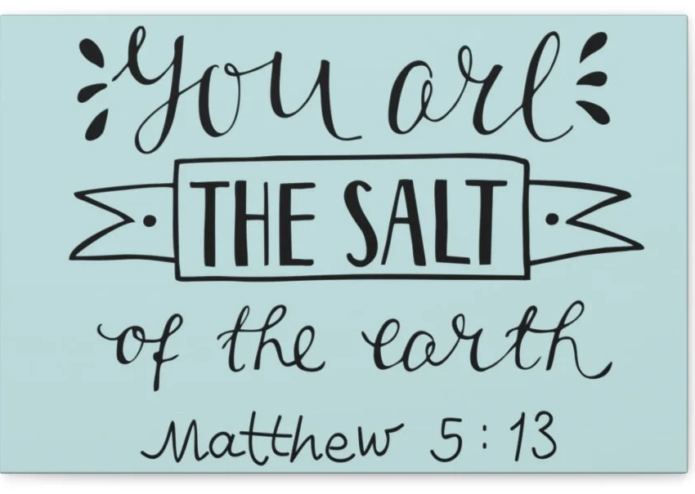

Light shines in the darkness for the upright, the psalmist sings. Isaiah declares that when we loose the bonds of injustice and share our bread with the hungry, the light breaks forth like the dawn. In another passage from the Sermon on the Mount, Jesus, the light of the world, calls his followers to let the light of their good works shine before others. Through baptism we are sent into the world to shine with the light of Christ.

Preservice: Bring Forth the Kingdom W&P 22
Welcome and Sharing of Congregational News
Prelude

Confession and Forgiveness
All may make the sign of the cross, the sign that is marked at baptism, as the presiding minister begins.
Blessed be the holy Trinity, ☩ one God,
the Creator of heaven and earth,
the Word who spoke life into being,
the Wind stirring the waters.
Amen.
Let us turn in confession to the one who knows us completely.
Silence is kept for reflection.
Mighty God, lover of justice,
you call us to life in community,
but we have served our own interests
at the expense of our neighbors.
We have sown deceit where honesty was needed.
We say the right words,
but our hearts are far from you.
Turn us to seek your face.
Knit us together and give us the mind of Christ,
that we may do justice, love mercy,
and walk humbly with you, our God.
Amen.

Forgiveness
The former things have passed away,
and new things God now declares:
Like a spring of water that never fails,
God covers you in the righteousness of Christ,
and forgives your sin in ☩ Jesus’ name.
May the Spirit give you strength to live for others,
and bless you with the gift of peace.
Amen.
Greeting
P: The joy of our Lord Jesus Christ, the compassion of God, and the creative power of the Holy Spirit be with you all.
C: And also with you.

Gathering Hymn: Gather Us In ELW 532
1 Here in this place the new light is streaming, now is the darkness vanished away; see in this space our fears and our dreamings
brought here to you in the light of this day.
Gather us in, the lost and forsaken, gather us in, the
blind and the lame; call to us now, and we shall awaken,
we shall arise at the sound of our name.

2 We are the young, our lives are a myst'ry, we are the old who yearn for your face; we have been sung throughout all of hist'ry,
called to be light to the whole human race.
Gather us in, the rich and the haughty, gather us in, the
proud and the strong; give us a heart, so meek and so lowly,
give us the courage to enter the song.

3 Here we will take the wine and the water, here we will take the bread of new birth, here you shall call your sons and your daughters,
call us anew to be salt for the earth.
Give us to drink the wine of compassion, give us to eat the
bread that is you; nourish us well, and teach us to fashion
lives that are holy and hearts that are true.

4 Not in the dark of buildings confining, not in some heaven,
light years away—here in this place the new light is shining,
now is the kingdom, and now is the day.
Gather us in and hold us forever, gather us in and
make us your own; gather us in, all peoples together,
fire of love in our flesh and our bone.

Text: Marty Haugen, b. 1950
Text © 1982 GIA Publications, Inc. All rights reserved.

Prayer of the Day
Lord God, with endless mercy you receive the prayers of all who call upon you. By your Spirit show us the things we ought to do, and give us the grace and power to do them, through Jesus Christ, our Savior and Lord.
Amen.
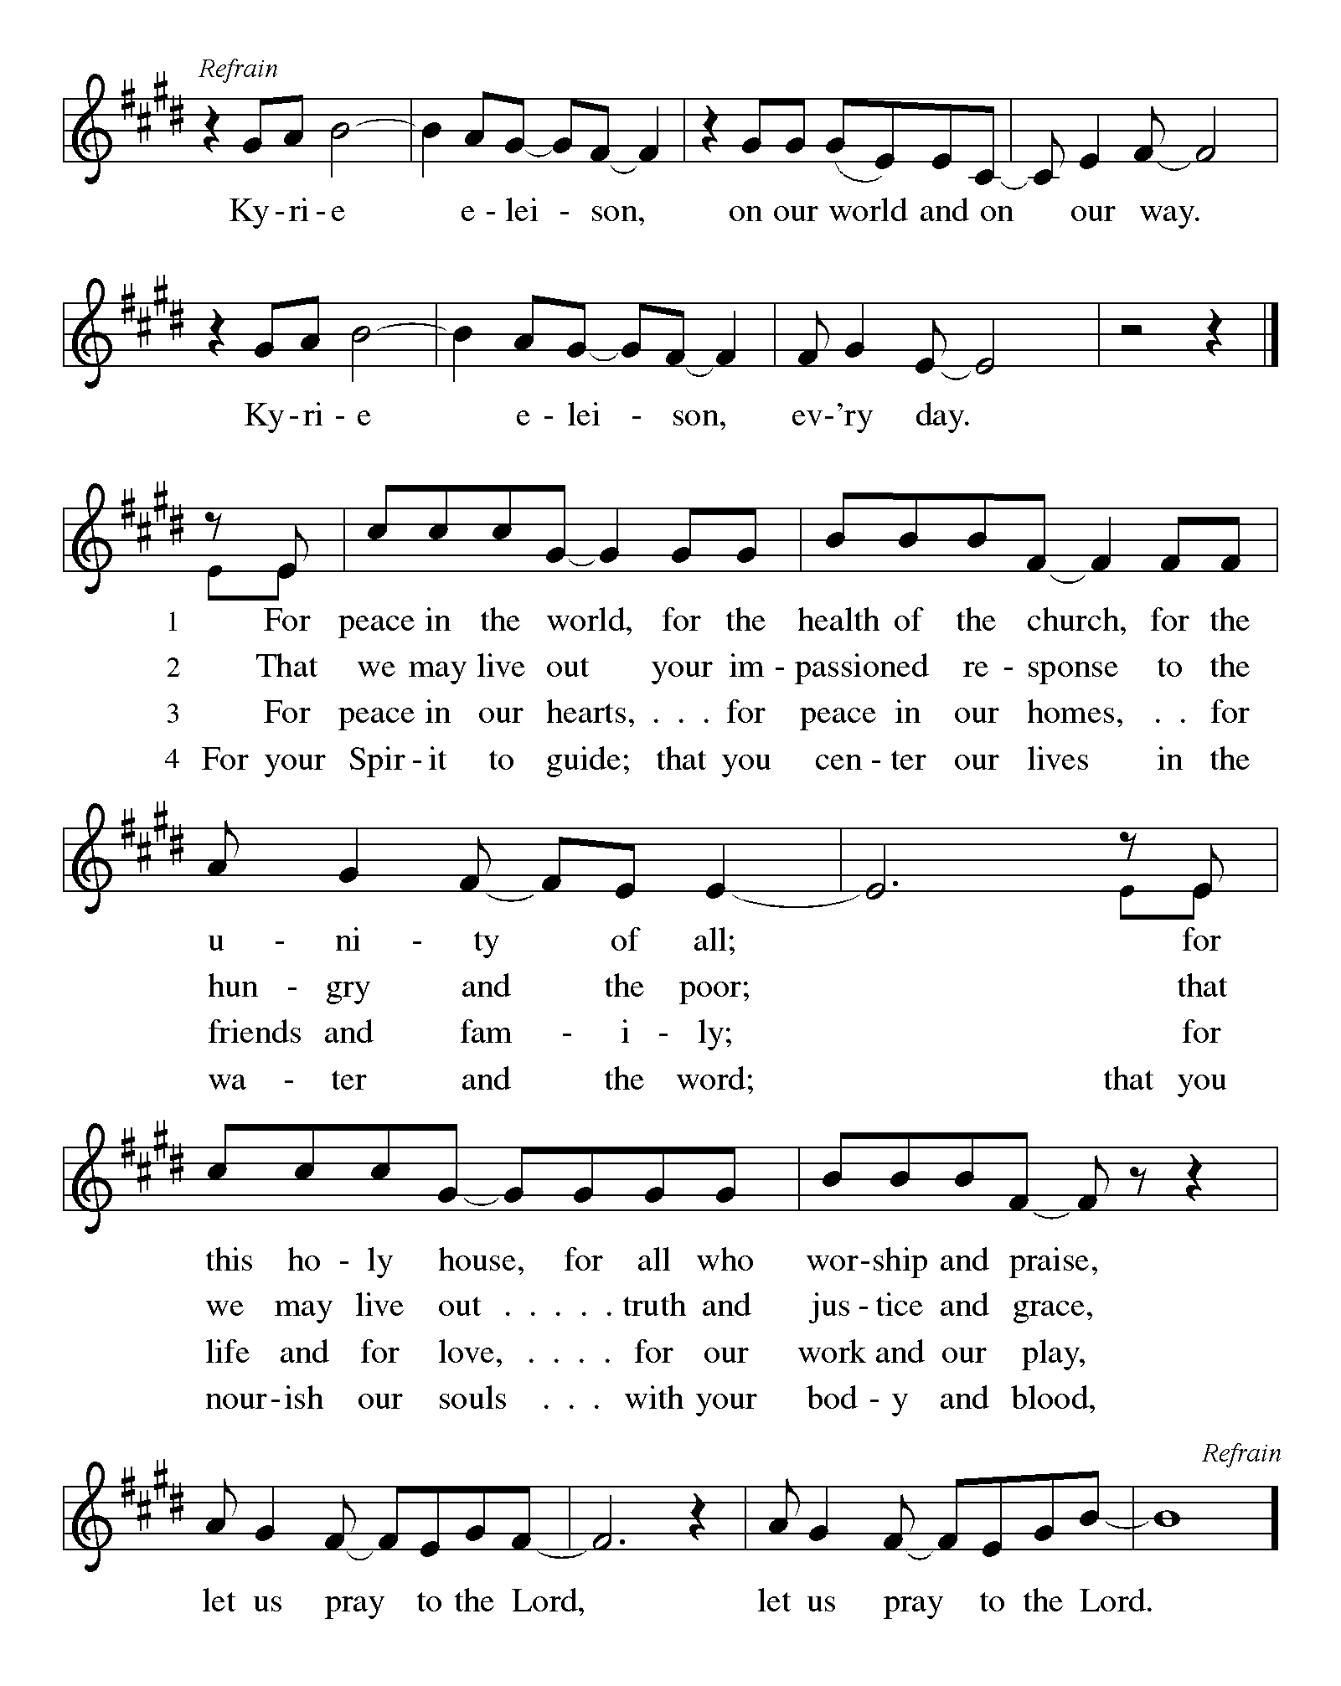

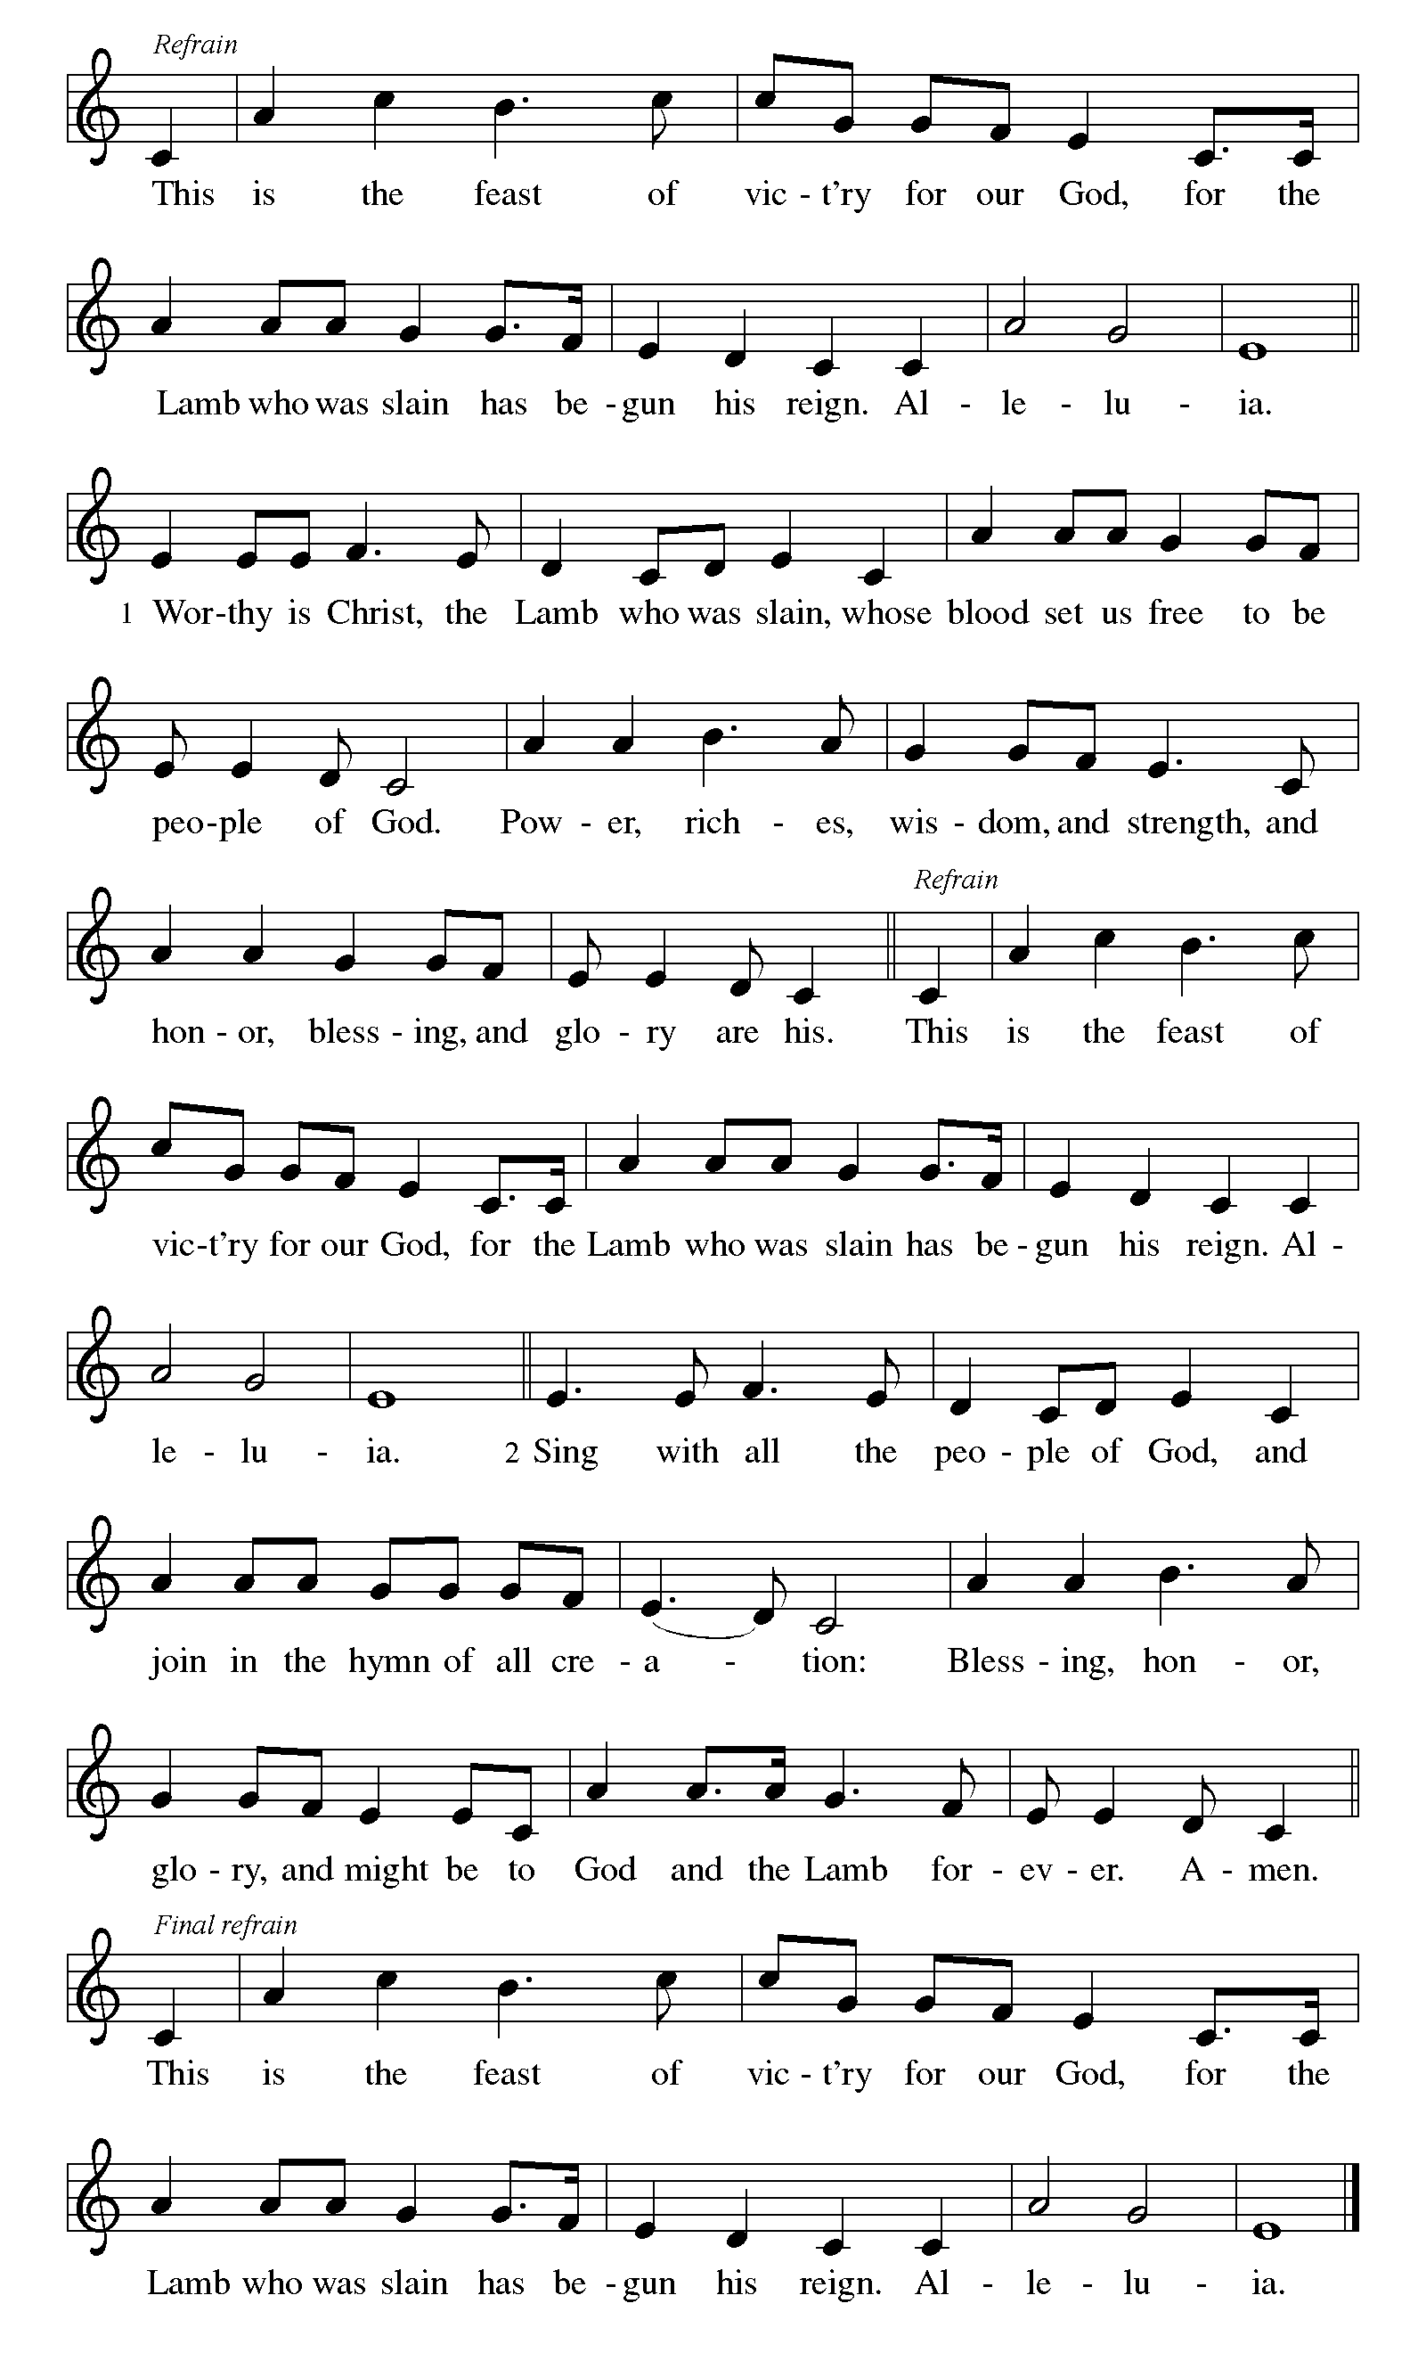

First Reading: Isaiah 58:1-9a [9b-12]
Shortly after the return of Israel from exile in Babylon, the people were troubled by the ineffectiveness of their fasts. God reminds them that outward observance is no substitute for genuine fasting that results in acts of justice, such as feeding the hungry, sheltering the homeless, and clothing the naked.
¹ Shout out; do not hold back!
Lift up your voice like a trumpet!
Announce to my people their rebellion,
to the house of Jacob their sins.
² Yet day after day they seek me
and delight to know my ways,
as if they were a nation that practiced righteousness
and did not forsake the ordinance of their God;
they ask of me righteous judgments;
they want God on their side.
³ “Why do we fast, but you do not see?
Why humble ourselves, but you do not notice?”
Look, you serve your own interest on your fast day
and oppress all your workers.
⁴ You fast only to quarrel and to fight
and to strike with a wicked fist.
Such fasting as you do today
will not make your voice heard on high.
⁵ Is such the fast that I choose,
a day to humble oneself?
Is it to bow down the head like a bulrush
and to lie in sackcloth and ashes?
Will you call this a fast,
a day acceptable to the Lord?
⁶ Is not this the fast that I choose:
to loose the bonds of injustice,
to undo the straps of the yoke,
to let the oppressed go free,
and to break every yoke?
⁷ Is it not to share your bread with the hungry
and bring the homeless poor into your house;
when you see the naked, to cover them
and not to hide yourself from your own kin?
⁸ Then your light shall break forth like the dawn,
and your healing shall spring up quickly;
your vindicator shall go before you;
the glory of the Lord shall be your rear guard.
^{9a} Then you shall call, and the Lord will answer;
you shall cry for help, and he will say, “Here I am.”
^{9b} If you remove the yoke from among you,
the pointing of the finger, the speaking of evil,
¹⁰ if you offer your food to the hungry
and satisfy the needs of the afflicted,
then your light shall rise in the darkness
and your gloom be like the noonday.
¹¹ The Lord will guide you continually
and satisfy your needs in parched places
and make your bones strong,
and you shall be like a watered garden,
like a spring of water
whose waters never fail.
¹² Your ancient ruins shall be rebuilt;
you shall raise up the foundations of many generations;
you shall be called the repairer of the breach,
the restorer of streets to live in.

P: Here ends our first reading.
C: Thanks be to God!

Psalm 112:1-9 [10]
¹ Hallelujah! Happy are they who fear the Lord
and have great delight in God’s commandments!
² Their descendants will be mighty in the land;
the generation of the upright will be blessed.
³ Wealth and riches will be in their house,
and their righteousness will last forever.
⁴ Light shines in the darkness for the upright;
the righteous are merciful and full of compassion.
⁵ It is good for them to be generous in lending
and to manage their affairs with justice.
⁶ For they will never be shaken;
the righteous will be kept in everlasting remembrance.
⁷ They will not be afraid of any evil rumors;
their heart is steadfast, trusting in the Lord.
⁸ Their heart is established and will not shrink,
until they see their desire upon their enemies.
⁹ They have given freely to the poor, and their righteousness stands fast forever;
they will hold up their head with honor.
¹⁰ The wicked will see it and be angry; they will gnash their teeth and pine away;
the desires of the wicked will perish.

Second Reading: 1 Corinthians 2:1-12 [13-16]
Though people such as the Corinthians are enamored with human philosophy and wisdom, Paul continuously presents God’s hidden wisdom which is Jesus Christ crucified. True spiritual maturity involves judging ourselves and others in light of God’s revelation in the cross.
¹ When I came to you, brothers and sisters, I did not come proclaiming the testimony of God to you with superior speech or wisdom. ² For I decided to know nothing among you except Jesus Christ and him crucified. ³ And I came to you in weakness and in fear and in much trembling. ⁴ My speech and my proclamation were made not with persuasive words of wisdom but with a demonstration of the Spirit and of power, ⁵ so that your faith might rest not on human wisdom but on the power of God.
⁶ Yet among the mature we do speak wisdom, though it is not a wisdom of this age or of the rulers of this age, who are being destroyed. ⁷ But we speak God’s wisdom, a hidden mystery, which God decreed before the ages for our glory ⁸ and which none of the rulers of this age understood, for if they had, they would not have crucified the Lord of glory. ⁹ But, as it is written,
“What no eye has seen, nor ear heard,
nor the human heart conceived,
what God has prepared for those who love him”—
¹⁰ God has revealed to us through the Spirit, for the Spirit searches everything, even the depths of God. ¹¹ For what human knows what is truly human except the human spirit that is within? So also no one comprehends what is truly God’s except the Spirit of God. ¹² Now we have received not the spirit of the world but the Spirit that is from God, so that we may understand the gifts bestowed on us by God. [¹³ And we speak of these things in words not taught by human wisdom but taught by the Spirit, interpreting spiritual things to those who are spiritual.
¹⁴ Those who are unspiritual do not receive the gifts of God’s Spirit, for they are foolishness to them, and they are unable to understand them because they are spiritually discerned. ¹⁵ Those who are spiritual discern all things, and they are themselves subject to no one else’s scrutiny.
¹⁶ “For who has known the mind of the Lord
so as to instruct him?”
But we have the mind of Christ.]
P: Here ends our second reading.
C: Thanks be to God!
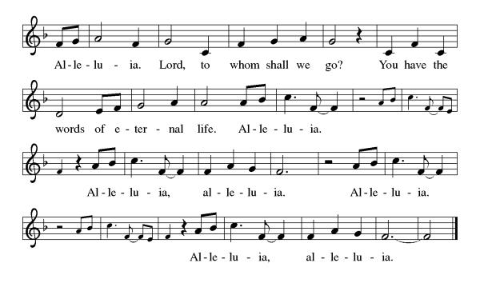
Gospel Acclamation

P: The Holy Gospel according to Matthew 5:13-20
C: Glory to you O Lord.

Gospel: Matthew 5:13-20
In the Sermon on the Mount, Jesus encourages his followers to be the salt of the earth and the light of the world, doing good works and keeping God’s commandments.
[Jesus said:] ¹³ “You are the salt of the earth, but if salt has lost its taste, how can its saltiness be restored? It is no longer good for anything but is thrown out and trampled under foot.
¹⁴ “You are the light of the world. A city built on a hill cannot be hid. ¹⁵ People do not light a lamp and put it under the bushel basket; rather, they put it on the lampstand, and it gives light to all in the house. ¹⁶ In the same way, let your light shine before others, so that they may see your good works and give glory to your Father in heaven.
¹⁷ “Do not think that I have come to abolish the Law or the Prophets; I have come not to abolish but to fulfill. ¹⁸ For truly I tell you, until heaven and earth pass away, not one letter, not one stroke of a letter, will pass from the law until all is accomplished. ¹⁹ Therefore, whoever breaks one of the least of these commandments and teaches others to do the same will be called least in the kingdom of heaven, but whoever does them and teaches them will be called great in the kingdom of heaven. ²⁰ For I tell you, unless your righteousness exceeds that of the scribes and Pharisees, you will never enter the kingdom of heaven.”

P: The Gospel of Our Lord!
C: Praise to You O Christ!
Sermon by Bob

Hymn of the Day: Rise, Shine, You People! ELW 665
1 Rise, shine, you people! Christ the Lord has entered
our human story; God in him is centered. He comes to
us, by death and sin surrounded, with grace unbounded.

2 See how he sends the pow'rs of evil reeling;
he brings us freedom, light and life and healing. All men and women, who by guilt are driven, now are forgiven.

3 Come, celebrate; your banners high unfurling,
your songs and prayers against the darkness hurling. To all the world go out and tell the story of Jesus' glory.

4 Tell how the Father sent the Son to save us.
Tell of the Son, who life and freedom gave us. Tell how the
Spirit calls from ev'ry nation God's new creation.
Text: Ronald A. Klug, b. 1939, alt.
Text © 1974 Augsburg Publishing House, admin. Augsburg Fortress.

Apostles’ Creed
I believe in God, the Father almighty,
creator of heaven and earth.
I believe in Jesus Christ, God’s only Son, our Lord,
who was conceived by the Holy Spirit,
born of the virgin Mary,
suffered under Pontius Pilate,
was crucified, died, and was buried;
he descended to the dead.
On the third day he rose again;
he ascended into heaven,
he is seated at the right hand of the Father,
and he will come to judge the living and the dead.
I believe in the Holy Spirit,
the holy catholic church,
the communion of saints,
the forgiveness of sins,
the resurrection of the body,
and the life everlasting. Amen.

Lord, listen to your children praying,
Lord, send your Spirit in this place;
Lord, listen to your children praying,
send us love, send us pow'r, send us grace.

Prayers of the People
Response (after “Merciful God”): “Keep us in constant prayer”

Confident that the Holy Spirit receives our prayers and answers us, we commend all for whom we pray to God’s loving-kindness made known to us in Christ Jesus our Savior.
Amen.
P: May the peace of our Lord Jesus Christ be with you all.
C: And also with you.
P: Let us now share this peace.
Offering is Brought to the Altar

Offertory Prayer
God of majesty,
no eye has seen, no ear has heard
what you have prepared for those who love you,
yet in this meal you reveal the wideness of your mercy.
Use what we have gathered
to feed us with the reign of God come near,
Jesus Christ, our Savior and Lord.
Amen.
P: The Lord be with you.
C: And also with you.

P: Lift up your hearts.
C: Lift them to the Lord.

P: Let us give thanks to the Lord our God.
C: It is right to give our thanks and praise.

Preface
(Words spoken by Bob)

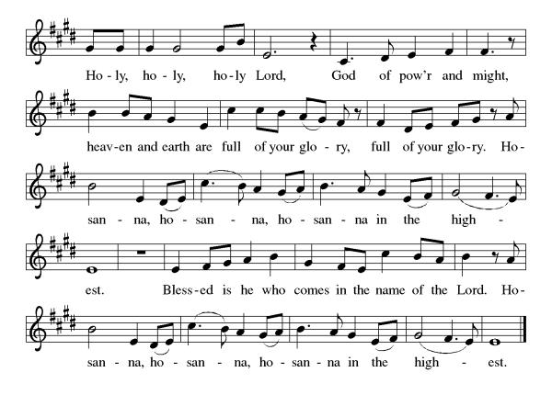
Eucharistic Prayer
(Words of Institution)

For as often as we eat of this bread and drink from this cup we proclaim the Lord’s death until He comes.
Christ has died
Christ is risen.
Christ will come again.
Gathered into one, by the Holy Spirit let us listen to the words that Jesus taught us.

The Lord’s Prayer
Our Father, who art in heaven, hallowed be thy name, thy kingdom come, thy will be done, on earth as it is in heaven. Give us this day our daily bread; and forgive us our trespasses, as we forgive those who trespass against us; and lead us not into temptation but deliver us from evil. For thine is the kingdom, and the power, and the glory, forever and ever. Amen.

Invitation to Communion
P: Here is the Lamb of God who takes away the sins of the world! Come to His table and taste on your lips a Love we cannot comprehend.
C: Amen
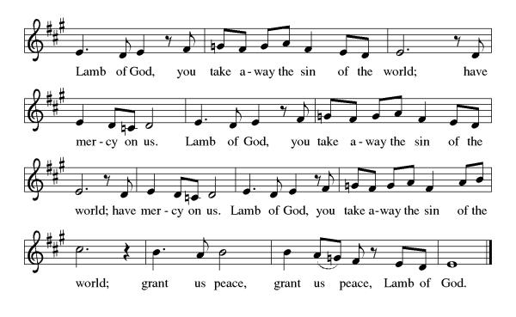

All may come.
Communion Anthem: Jesus, the Light of the World ACS 914
P: We are now a tabernacle with Christ inside of us. Let us rejoice and be glad at the Lord’s table.
C: Amen

Prayer after Communion
Radiant God,
we have seen your glory in the face of Jesus Christ.
In the sacrament of his body and blood
you have drawn us to your heart.
Send us from this table with delight,
that our lives may reflect the beauty of your love,
and bear witness to all we have seen and heard,
through Jesus Christ, our Savior and Lord.
Amen.

Blessing
May the triune God,
Who has put a new song in your mouth
And tuned your heart for praise
☩ bless you now and forever
Amen.

Sending Hymn: This Little Light of Mine ELW 677
1 This little light of mine, I'm goin'-a let it shine;
this little light of mine, I'm goin'-a let it shine;
this little light of mine, I'm goin'-a let it shine,
let it shine, let it shine, let it shine.

2 Ev'rywhere I go, I'm goin'-a let it shine;
ev'rywhere I go, I'm goin'-a let it shine;
ev'rywhere I go, I'm goin'-a let it shine,
let it shine, let it shine, let it shine.

3 Jesus gave it to me, I'm goin'-a let it shine;
Jesus gave it to me, I'm goin'-a let it shine;
Jesus gave it to me, I'm goin'-a let it shine,
let it shine, let it shine, let it shine.

Text: African American spiritual

Dismissal
P: Go in peace. Do justice. Love mercy.
C: Thanks be to God.
Postlude
Unless otherwise noted, materials used in this bulletin are:
From Sundays and Seasons.com. Copyright 2015 Augsburg Fortress. All rights reserved. Reprinted by permission under Augsburg Fortress Liturgies Annual License #SAS028635. Music is reprinted under OneLicense.Net #A712074 and/or Augsburg Fortress #SBL12176H. Scripture, unless otherwise noted, is from the New Revised Standard Version Bible, Copyright © 1989, Division of Christian Education of the National Council of the Churches of Christ in the United States of America. Used by permission. All rights reserved.

St. Timothy Evangelical Lutheran Church
1070 N. Suncoast Blvd.
Crystal River, FL 34429
Telephone number (Office): 352-795-5325
Office email address: crsttimothy@tampabay.rr.com

St Timothy Worship Team
S.A.M. Robert F. Bonomo
Lay Minister, Frank Hofstetter
Director of Music, Sally Hennessey
Saturday Pianist, Bill Robinson

Announcements for February 7th & 8th

ATTENDANCE
Saturday, January 31st, 4pm 24
Sunday, February 1st, 9am 47
Drive-Up Communion 0
71

The Altar Flowers are given this week by Debbie Lawrence, in memory of her parents’ anniversary!

Serving our Lord this weekend:
Saturday
Assisting Minister- Carolyn Fialkowski, Reader – Ed Fialkowski, Altar Angel – Carolyn Fialkowski
Sunday
Reader – Kris Harper, Communion Assistant – Sarah Brisson

This Week at St. Timothy's
Monday, February 9th 10:30 Ruth Circle @ Barb C’s house
Tuesday, February 10th 9-12 Food Pantry
Wednesday, February 11th 1pm Worship & Music
Thursday, February 12th 11am Bible Study for Beginners (bring bible) 11am – Miniatures, 4:30pm - Choir
Friday, February 13th 8am-2pm – Mini Granny’s Attic/Bake Sale
Saturday, February 14th 4pm - Worship
Sunday, February 15th 9am – Worship, 10:15-10:45 – Drive Up Communion, Adult SS, Coffee Fellowship, Council



2026 MINI GRANNY’S ATTIC
Where: ST. TIMOTHY LUTHERAN CHURCH
1070 N. SUNCOAST BLVD.
CRYSTAL RIVER, FL 34429
(352) 795-5325

When: FRIDAY, FEBRUARY 13, 2026
8:00 am to 2:00 pm

What: Delicious homemade goodies in the Bake Shop
Ever-popular men’s outdoor treasures
Terrific Buys Throughout Granny’s Attic

Save the date. Come join in the fun!

MINI GRANNY’S ATTIC

CALLING ALL BAKERS!!!
We need cookies, cakes, cupcakes, brownies, candy, breads, etc. for our Bake Sale on
Friday, February 13, 2026.
- You may package your goodies, or we can
do that for you.
- Please mark the goodies if they are gluten
free and/or sugar free.
- Please note if there are nuts in the baked
goods.
- Please bring the items to the Church
either Thursday, February 12th or early
Friday morning, February 13th.

Thanks so much for your help and support.

Questions: Call Eileen at 352-419-6610 or Lynn at 352-382-0435.

