St Timothy Lutheran Church
Saturday, September 5th, 2026

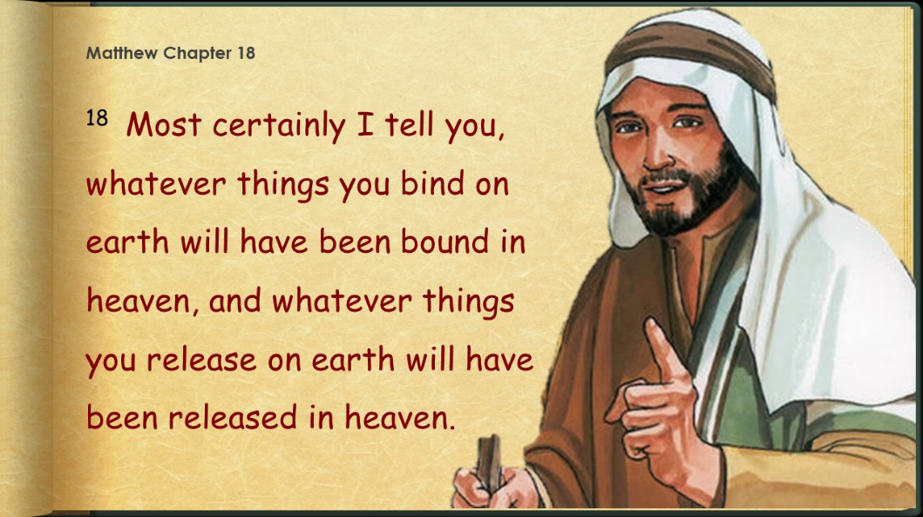

Conflict is a part of relationships and life in community. Jesus’ words in today's gospel are often used in situations having to do with church discipline. The prophet Ezekiel tells of warning the wicked to turn from their ways, and Paul reminds us that love is the fulfilling of the law. We gather in the name of Christ, assured that he is present among us with gifts of peace and reconciliation.
Preservice: Jesus in the Morning TFF 167
Welcome!
Prelude

Confession and Forgiveness
All may make the sign of the cross, the sign that is marked at baptism, as the presiding minister begins.
Blessed be the holy Trinity,☩ one God,
whose compassion endures forever.
Amen.
Let us confess our sin to God.
Silence is kept for reflection.
Compassionate God,
we confess to you all our sins.
Our burden is heavy, and we cannot free ourselves.
In your mercy, call us back to you.
Your yoke is easy and your burden is light.
Restore us to dwell in your peace.
In Christ’s name we pray,
Amen.
Jesus says, “Come to me,
all you who are weary
and are carrying heavy burdens,
and I will give you rest.”
In the name of God,
Father, ☩ Son, and Holy Spirit,
your sins are forgiven.
Rest in God’s love.
Amen.
Gathering Hymn: Shall We Gather at the River ELW 423
1 Shall we gather at the river, where bright angel feet have trod,
with its crystal tide forever flowing by the throne of God?

Refrain
Yes, we'll gather at the river, the beautiful, the beautiful river;
gather with the saints at the river that flows by the throne of God.

2 On the margin of the river, washing up its silver spray,
we will walk and worship ever, all the happy golden day. Refrain

3 Ere we reach the shining river, lay we ev'ry burden down;
grace our spirits will deliver, and provide a robe and crown. Refrain

4 Soon we'll reach the shining river, soon our pilgrimage will cease;
soon our happy hearts will quiver with the melody of peace. Refrain
Text: Robert Lowry, 1826-1899

P - The grace of our Lord Jesus Christ, the love of God and the communion of the Holy Spirit be with you all.
C - And also with you.

Prayer of the Day
O Lord God, enliven and preserve your church with your perpetual mercy. Without your help, we mortals will fail; remove far from us everything that is harmful, and lead us toward all that gives life and salvation, through Jesus Christ, our Savior and Lord.
Amen.

First Reading: Ezekiel 33:7-11
God appointed Ezekiel as a sentinel for the house of Israel. Ezekiel must faithfully convey God’s warnings to the people. Remarkably, God—who is about to attack Jerusalem—gives a warning with the hope that repentance will make the attack unnecessary.
⁷ So you, mortal, I have made a sentinel for the house of Israel; whenever you hear a word from my mouth, you shall give them warning from me. ⁸ If I say to the wicked, “O wicked ones, you shall surely die,” and you do not speak to warn the wicked to turn from their ways, the wicked shall die in their iniquity, but their blood I will require at your hand. ⁹ But if you warn the wicked to turn from their ways and they do not turn from their ways, the wicked shall die in their iniquity, but you will have saved your life.
¹⁰ Now you, mortal, say to the house of Israel: Thus you have said: “Our transgressions and our sins weigh upon us, and we waste away because of them; how then can we live?” ¹¹ Say to them: As I live, says the Lord God, I have no pleasure in the death of the wicked but that the wicked turn from their ways and live; turn back, turn back from your evil ways, for why will you die, O house of Israel?

A – Here ends the reading!
C – Thanks be to God!
P - The Holy Gospel according to Matthew, the 18th Chapter
C - Glory to You O Lord!

Gospel: Matthew 18:15-20
Jesus offers practical advice to his disciples on how individuals—and the church as a whole—should go about restoring relationships when one member has sinned against another.
[Jesus said to the disciples:] ¹⁵ “If your brother or sister sins against you, go and point out the fault when the two of you are alone. If you are listened to, you have regained that one. ¹⁶ But if you are not listened to, take one or two others along with you, so that every word may be confirmed by the evidence of two or three witnesses. ¹⁷ If that person refuses to listen to them, tell it to the church, and if the offender refuses to listen even to the church, let such a one be to you as a gentile and a tax collector. ¹⁸ Truly I tell you, whatever you bind on earth will be bound in heaven, and whatever you loose on earth will be loosed in heaven. ¹⁹ Again, truly I tell you, if two of you agree on earth about anything you ask, it will be done for you by my Father in heaven. ²⁰ For where two or three are gathered in my name, I am there among them.”

P - The Gospel of the Lord.
C – Praise to you, O Christ!
Sermon by S.A.M. Robert Bonomo

Hymn of the Day: God, When Human Bonds Are Broken ELW 603
1 God, when human bonds are broken and we lack the love or skill
to restore the hope of healing, give us grace and make us still.

2 Through that stillness, with your Spirit come into our world of stress,
for the sake of Christ forgiving all the failures we confess.

3 You in us are bruised and broken: hear us as we seek release
from the pain of earlier living; set us free and grant us peace.

4 Send us, God of new beginnings, humbly hopeful into life.
Use us as a means of blessing: make us stronger, give us faith.

5 Give us faith to be more faithful, give us hope to be more true,
give us love to go on learning: God, encourage and renew!

Text: Fred Kaan, b. 1929
Text © 1989 Hope Publishing Company, Carol Stream, IL 60188. All rights reserved. Used by permission.
Duplication in any form prohibited without permission or valid license from copyright administrator.

The Apostle’s Creed
I believe in God, the Father almighty,
creator of heaven and earth.
I believe in Jesus Christ, God’s only Son, our Lord,
who was conceived by the Holy Spirit,
born of the virgin Mary,
suffered under Pontius Pilate,
was crucified, died, and was buried;
he descended to the dead.*
On the third day he rose again;
he ascended into heaven,
he is seated at the right hand of the Father,
and he will come to judge the living and the dead.
I believe in the Holy Spirit,
the holy catholic church,
the communion of saints,
the forgiveness of sins,
the resurrection of the body,
and the life everlasting. Amen.
From sundaysandseasons.com.
Copyright © 2026 Augsburg Fortress. All rights reserved.

Prayers of the People
Reminded of God’s gracious and abundant love, we offer our prayers, confident that God hears us. Help us Lord to focus on reconciliation, unity, and You in prayer.

Brief Silence
Holy Lord, all glory and praise are offered to You, for You are our Redeemer and King, our Savior and Friend. We adore You and exalt Your holy name.
Lord in Your mercy
Help us to pray
Gathering God, resolve conflicts in this community through Your righteousness and grace. Reconcile us to each other, making Your good news known even through our imperfections.
Lord in Your mercy
Help us to pray
Reign over us, not according to our human planning and perceptions, but according to Your good and gracious will. Shape our attitude to be like Yours, living a life of humility and obedience.
Lord in Your mercy
Help us to pray
Merciful Lord, Your grace is sufficient for all our needs. You have promised to be the strength of the weary, the hope of those who fear, the healing of the ill, the fullness of those disabled, and the peace of all who are distressed. Wake us up to any around us who are in need, that they may be well supplied by Your grace in every time of trouble. Restore broken relationships, failing health, frayed emotions, and the hurts we carry with us.
Lord in Your mercy
Help us to pray
Although we have deserved Your righteous wrath and punishment, yet we ask You, O most merciful Father, not to remember our sins. For the sake of Your Son, Jesus Christ, have mercy on us and grant us Your forgiveness.
Lord in Your mercy
Help us to pray
Proclaiming God, empower Your church throughout the world to announce the Words You give us. Open us to receive Your Word in unexpected ways.
Lord in Your mercy
Help us to pray
Loving God, all who have died in faith have life with You. We give You thanks for the nearness of Your salvation for all who have gone before us.
Lord in Your mercy
Help us to pray
Grant the prayers we have offered, what we have forgotten to ask, and whatever else you see that we need. We ask this in the name of Your Son Jesus Christ.
Amen.

P – The Peace of the Lord be with you always.
C – And also with you.

The Offering is Brought to the Altar
Offering Prayer

We lift our voices, we lift our hands, we lift our lives up to you; we are an Offering. Lord, use our voices, Lord, use our hands, Lord, use our lives, they are yours: we are an offering. All that we have, all that we are, all that we hope to be, we give to you, we give to you. We lift our voices, we lift our hands, we lift our lives up to you; we are an offering, we are an offering.

The Great Thanksgiving

P – The Lord be with You
C – And also with you.
P – Lift up your hearts
C – We lift them to the Lord.
P – Let us give thanks to the Lord, our God
C – It is right to give Him our thanks and praise.

Preface
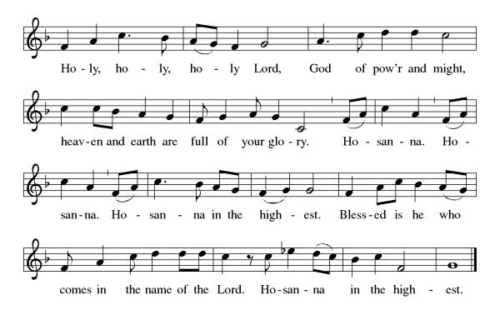
And so, with all the choirs of angels, with the church on earth and the hosts of heaven, we praise your name and join their unending hymn:

Eucharistic Prayer
(Words of Institution)
For as often as we eat of this bread and drink from this cup we proclaim the Lord’s death until He comes.
Christ has died
Christ is risen.
Christ will come again.
Remembering, therefore, his salutary command,
his life-giving passion and death, his glorious resurrection and ascension,
and the promise of his coming again,
we give thanks to you, O Lord God Almighty,
not as we ought but as we are able;
we ask you mercifully to accept our praise and thanksgiving and with your Word and Holy Spirit to bless us, your servants, and these your own gifts of bread and wine, so that we and all who share in the body and blood of Christ may be filled with heavenly blessing and grace,
and, receiving the forgiveness of sin,
may be formed to live as your holy people
and be given our inheritance with all your saints.
To you, O God, Father, Son, and Holy Spirit,
be all honor and glory in your holy church, now and forever. Amen.
Gathered into one, by the Holy Spirit let us listen to the words that Jesus taught us.

The Lord’s Prayer
Our Father, who art in heaven, hallowed be thy name, thy kingdom come, thy will be done, on earth as it is in heaven. Give us this day our daily bread; and forgive us our trespasses, as we forgive those who trespass against us; and lead us not into temptation but deliver us from evil. For thine is the kingdom, and the power, and the glory, forever and ever. Amen.
P: Taste and see that the Lord is good.
C: Thanks be to God.

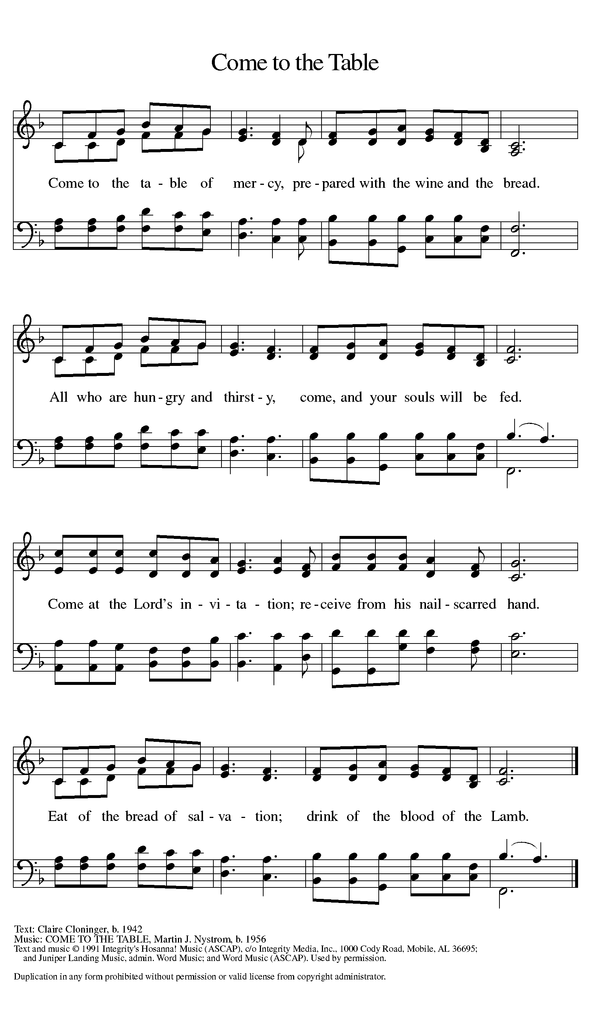
Invitation to Communion

Distribution of Communion – Come Forward to Receive
Communion Hymn: Would You Be Free (Power in the Blood) TFF 76
P – Now may the body and blood of our Lord and Savior Jesus Christ strengthen you and keep you in His grace!
C – Thank You Jesus!

Prayer after Communion
Compassionate God,
Through the gifts of bread and wine
our hearts are filled with the abundance of your love.
Strengthen us that we, through this Holy meal,
may share your love freely, as you have shared with us.
We ask this in the name of Jesus,
through the Spirit nourishing us now and forever.
Amen.

Words of dismissal and benediction
Know that the ever-present mystery we name God
was in your past forgiving you,
in your present loving you,
and in your future meeting you.
And may the blessing of the Source of life, love and hope,
the Word of life, compassion and wisdom
and Breath of life, grace and truth,
Father, ☩ Son, and Holy Spirit,
surround, sustain and surprise you,
this day and all your days. Amen.

Sending Hymn: Jesus Loves Me ELW 595
1 Jesus loves me! this I know, for the Bible tells me so;
little ones to him belong, they are weak, but he is strong.

Refrain
Yes, Jesus loves me, yes, Jesus loves me,
yes, Jesus loves me, the Bible tells me so.

2 Jesus loves me! he who died heaven's gates to open wide;
he will wash away my sin, let his little child come in. Refrain

3 Jesus loves me! he will stay close beside me all the way;
when at last I come to die, he will take me home on high. Refrain

Text: Anna B. Warner, 1820-1915, alt.

Dismissal
P – Look, and listen to S.A.M. Bob.
C- Thanks be to God.

Postlude:
Unless otherwise noted, service materials used in this bulletin are:
Music is reprinted under OneLicense.Net #A712074 and/or Augsburg Fortress #SBL12176H. Scripture, unless otherwise noted, is from the New Revised Standard Version Bible, Copyright © 1989, Division of Christian Education of the National Council of the Churches of Christ in the United States of America. Used by permission. All rights reserved.
St. Timothy’s is served by S.A.M. Robert “Bob” Bonomo
Lay Minister Frank Hofstetter
Director of Music Sally Hennessey
Saturday Pianist Bill Robinson

Announcements for September 5th and 6th
ATTENDANCE
Saturday, August 29th , 4pm 25
Sunday, August 30th 9am 56
Drive-Up Communion 2
81

The altar flowers are given this week by Barbara and Carol Johnson, in memory of Warren Johnson!
Serving our Lord this weekend:
Saturday, September 5th
Reader - Jean Fowler

Sunday, September 6th
Reader – Kris Harper
Altar Guild – Steve & Sarah Brisson

This Week at St. Timothy's
Monday, September 7th LABOR DAY – 10:30am PB&J, 11am Healthy Start
Tuesday, September 8th 9-12 Food Pantry
Wednesday, September 9th 10am Executive Council
Thursday, September 10th 11-12 Bible Study, 11am – Miniatures, 1pm – Dirty Dozen, 3pm – Worship & Music, 4:30 - Choir
Friday, September 11th
Saturday, September 12th 4pm Worship, No Fellowship
Sunday, September 13th 9am Worship (Special GWOH Liturgy), 10:30 – Adult SS, Coffee Fellowship, 12pm GWOH packing
PRAYER LIST
Phil
Sue
Dixie
Tyler
Marsha Gibson
Thea
May
Ben
Sarah Brisson
Sheila
Marie Demastus
Sharon Grimes
Ginny
Cindy
Mary Schlumberger
Marcia & Harry Treber
Baby Atticus
Teresa York
Debbie Lawrence
Carole Albert
Linda C.
Ashlee
Frani Barnes
Mark Duffy
Wyatt Toney
Jim & Rosa Neth
Melanie
Trish Bradley
Fowler Family
Marcus

